+91 9845728507 | srgreenscapes@gmail.com
Home | About Us | Services | Process | Project Portfolia | FAQ’S | Contact Us

Download Broacher

1. HOME PAGE
SR GREENSCAPES PVT LTD
Hero Section: 🌱 Sowing Science, Growing Beauty
Sub-headline: Science-Driven Sustainable Landscaping Across India
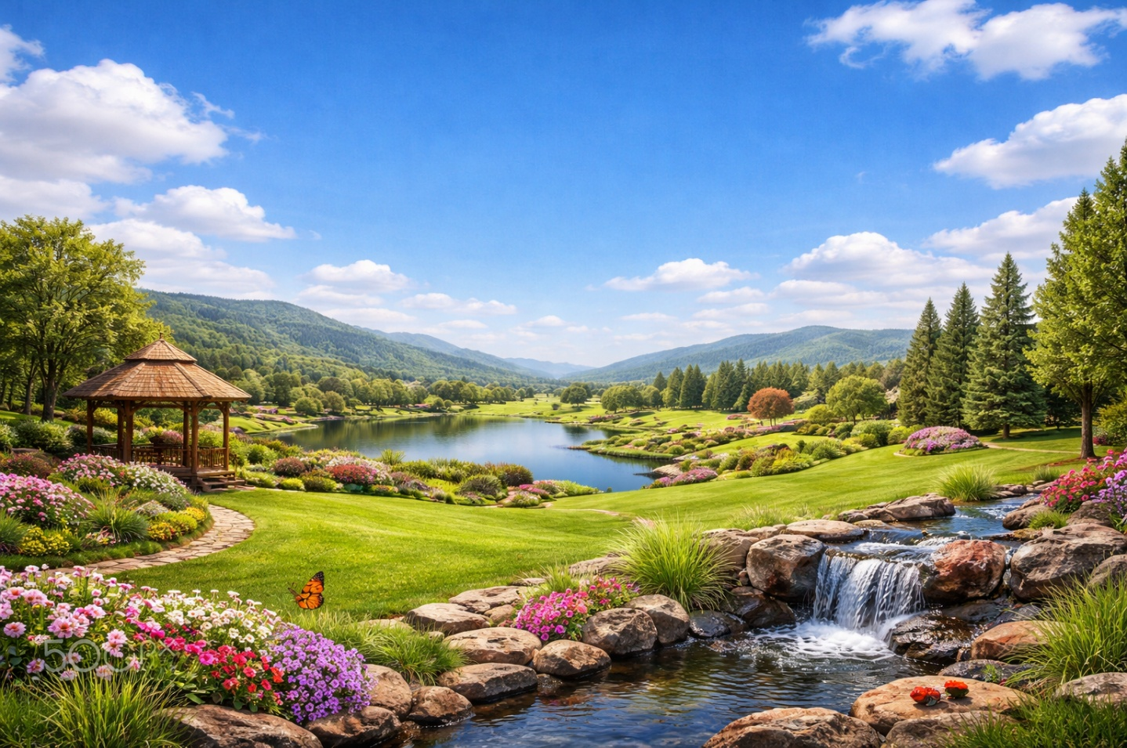
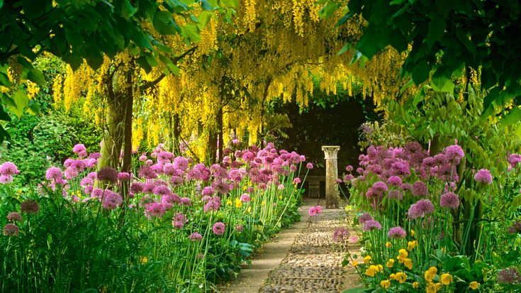

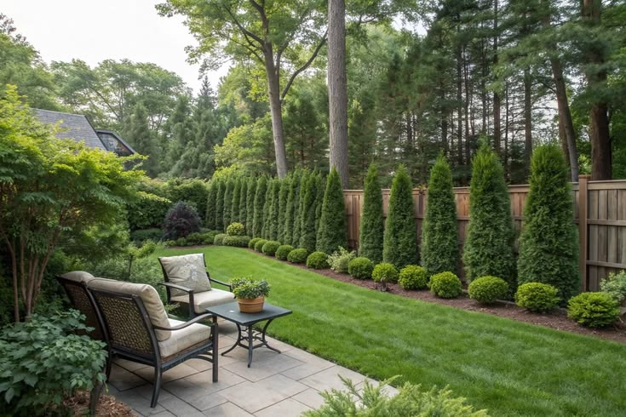

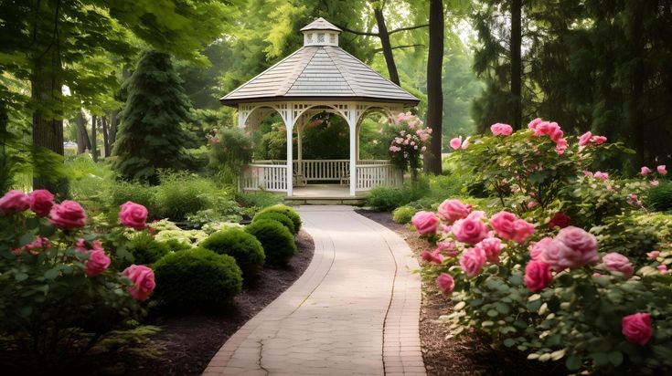

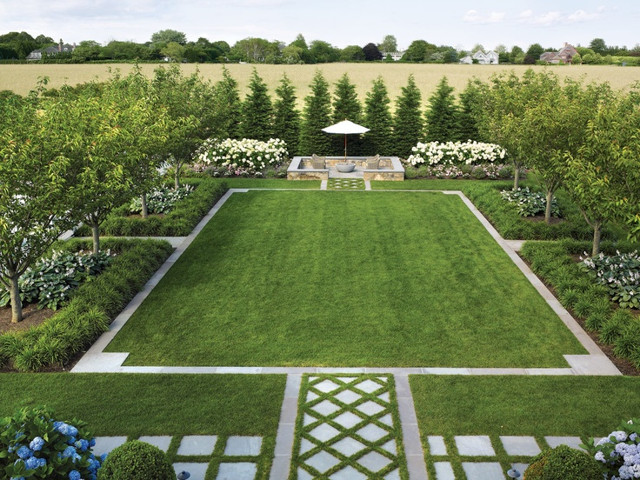

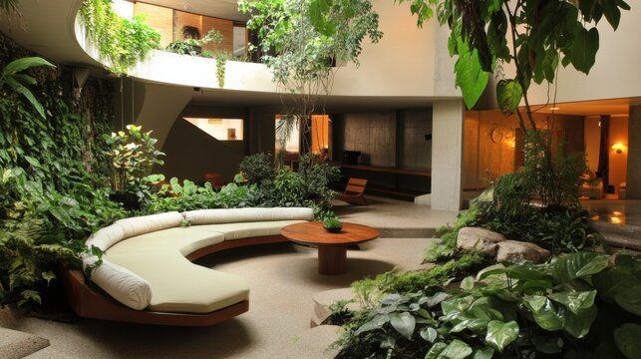

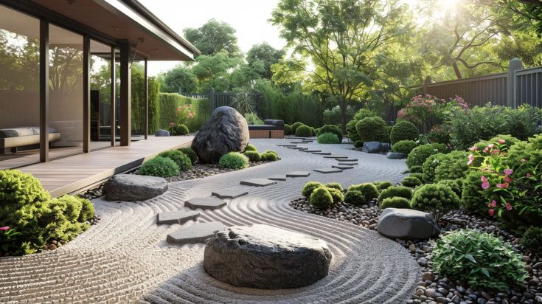
(5 to 6 Pics in sliding position)
Schedule a site visit (On the pic)
Name* Phone*

City Services*

Submit
Services: Residential, Commercial, Institutional, Industrial, Public Spaces, Maintenance, Vertical Gardening, Horticulture Consultancy, Nursery & Plant Supply, Green Gifts, Garden Supplies, Event Styling, Water bodies, Others
Chat with us


About Preview
Welcome to SR GREENSCAPES PVT LTD: Science-Driven Sustainable Landscapes
SR GREENSCAPES PVT LTD is a science-driven sustainable landscaping company creating eco-friendly, high-performance landscapes across India. We combine plant science, climate-responsive design and expert execution to deliver spaces that are beautiful, functional and built to last. From design to maintenance, we offer end-to-end green solutions for homes, commercial spaces, institutions and large-scale projects.

What Makes Us Different
  Science-Driven Approach  Every project is guided by scientific assessment, including soil analysis, plant suitability studies, and climate-responsive planning to ensure long-term landscape performance. |   Sustainability at the Core  Our landscapes are designed to conserve water, improve soil health, promote native biodiversity and reduce long-term maintenance costs- creating environmentally responsible and future-ready green spaces. |   Research-Integrated Planning  Backed by academic expertise and field trials, we integrate innovation, performance evaluation and evidence-based plant selection into every project. |   Climate-Resilient Design  We develop adaptive landscapes that withstand heat stress, irregular rainfall and urban environmental pressures- ensuring durability and ecological stability.
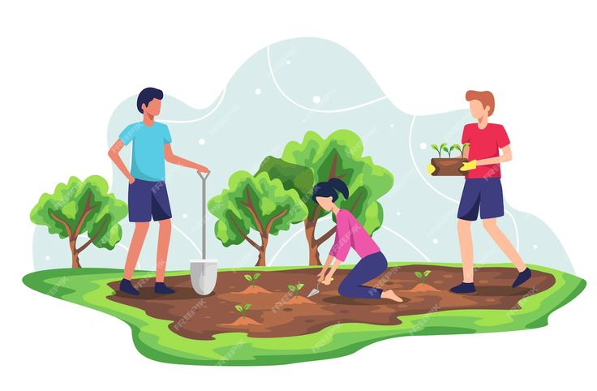  End-to-End Execution  From concept design and nursery production to irrigation systems and long-term maintenance, we provide complete, integrated green solutions under one roof. |   Experienced Leadership & Advisory Strength  Led by horticulture professionals and supported by a scientific advisory network, we bring institutional credibility and technical depth to every assignment. |   Long-Term Value Creation  Our focus is not just installation- but lifecycle performance, reduced resource use and sustained landscape health that delivers measurable value over time. |   Cost-Effective & Affordable  We deliver high-quality landscapes that balance performance, design and budget—ensuring maximum value through efficient planning, smart plant selection and optimized resource use
(Big Symbols followed by Bold title and small information)

What Makes Us Different
🧪 1. Science-Driven Approach
Every project is guided by scientific assessment, including soil analysis, plant suitability studies, and climate-responsive planning to ensure long-term landscape performance.

🌱 2. Sustainability at the Core
Our landscapes are designed to conserve water, improve soil health, promote native biodiversity and reduce long-term maintenance costs- creating environmentally responsible and future-ready green spaces.

📊 3. Research-Integrated Planning
Backed by academic expertise and field trials, we integrate innovation, performance evaluation and evidence-based plant selection into every project.

🌍 4. Climate-Resilient Design
We develop adaptive landscapes that withstand heat stress, irregular rainfall and urban environmental pressures- ensuring durability and ecological stability.

🏗 5. End-to-End Execution
From concept design and nursery production to irrigation systems and long-term maintenance, we provide complete, integrated green solutions under one roof.

👥 6. Experienced Leadership & Advisory Strength
Led by horticulture professionals and supported by a scientific advisory network, we bring institutional credibility and technical depth to every assignment.

💰 7. Long-Term Value Creation
Our focus is not just installation- but lifecycle performance, reduced resource use and sustained landscape health that delivers measurable value over time.

8. Cost-Effective & Affordable
We deliver high-quality landscapes that balance performance, design and budget—ensuring maximum value through efficient planning, smart plant selection and optimized resource use

Services
  Landscape Design & Execution (Learn More) | Specialized Garden Services (Learn More) | INCLUDEPICTURE "https://i.pinimg.com/736x/75/ec/b2/75ecb29eee50cf13f51d8fc2e512ed61.jpg" \* MERGEFORMATINET INCLUDEPICTURE "https://i.pinimg.com/736x/75/ec/b2/75ecb29eee50cf13f51d8fc2e512ed61.jpg" \* MERGEFORMATINET INCLUDEPICTURE "https://i.pinimg.com/736x/75/ec/b2/75ecb29eee50cf13f51d8fc2e512ed61.jpg" \* MERGEFORMATINET INCLUDEPICTURE "https://i.pinimg.com/736x/75/ec/b2/75ecb29eee50cf13f51d8fc2e512ed61.jpg" \* MERGEFORMATINET INCLUDEPICTURE "https://i.pinimg.com/736x/75/ec/b2/75ecb29eee50cf13f51d8fc2e512ed61.jpg" \* MERGEFORMATINET INCLUDEPICTURE "https://i.pinimg.com/736x/75/ec/b2/75ecb29eee50cf13f51d8fc2e512ed61.jpg" \* MERGEFORMATINET INCLUDEPICTURE "https://i.pinimg.com/736x/75/ec/b2/75ecb29eee50cf13f51d8fc2e512ed61.jpg" \* MERGEFORMATINET INCLUDEPICTURE "https://i.pinimg.com/736x/75/ec/b2/75ecb29eee50cf13f51d8fc2e512ed61.jpg" \* MERGEFORMATINET 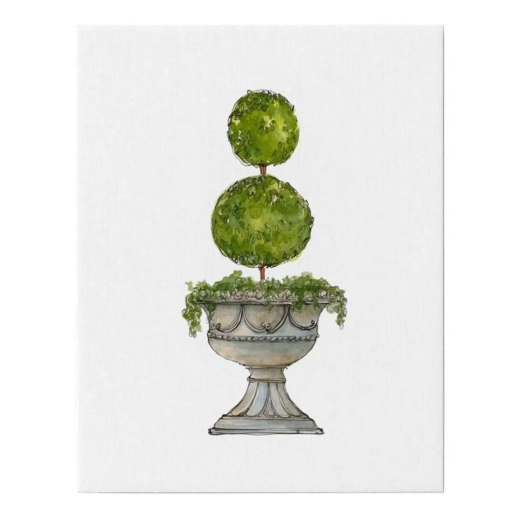  Hardscape & Softscape Development (Learn More)
  Landscape Maintenance (Learn More) | 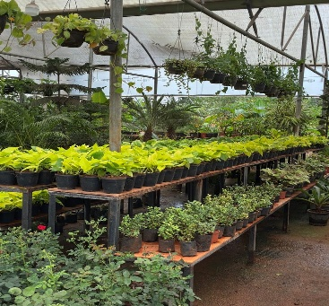  Nursery & Plant Supply (Learn More) |   Horticulture Consultancy (Learn More)
  Garden Supplies (Learn More) | 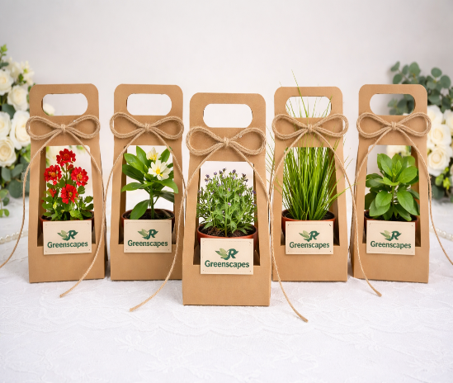  Green Gifts (Learn More) | 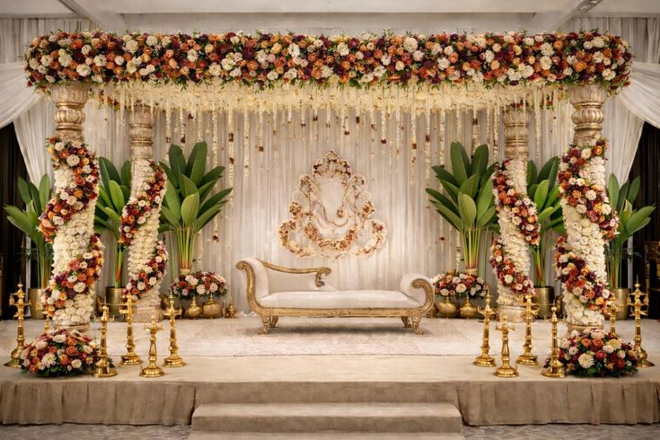  Event Styling (Learn More)

(Picture and Title in boxes- Clicking on Title, will take to Detailed Service Section)

Process (Pics with arrow mark and clicking on it should take to Process)
  Consultation & Site Assessment |  | 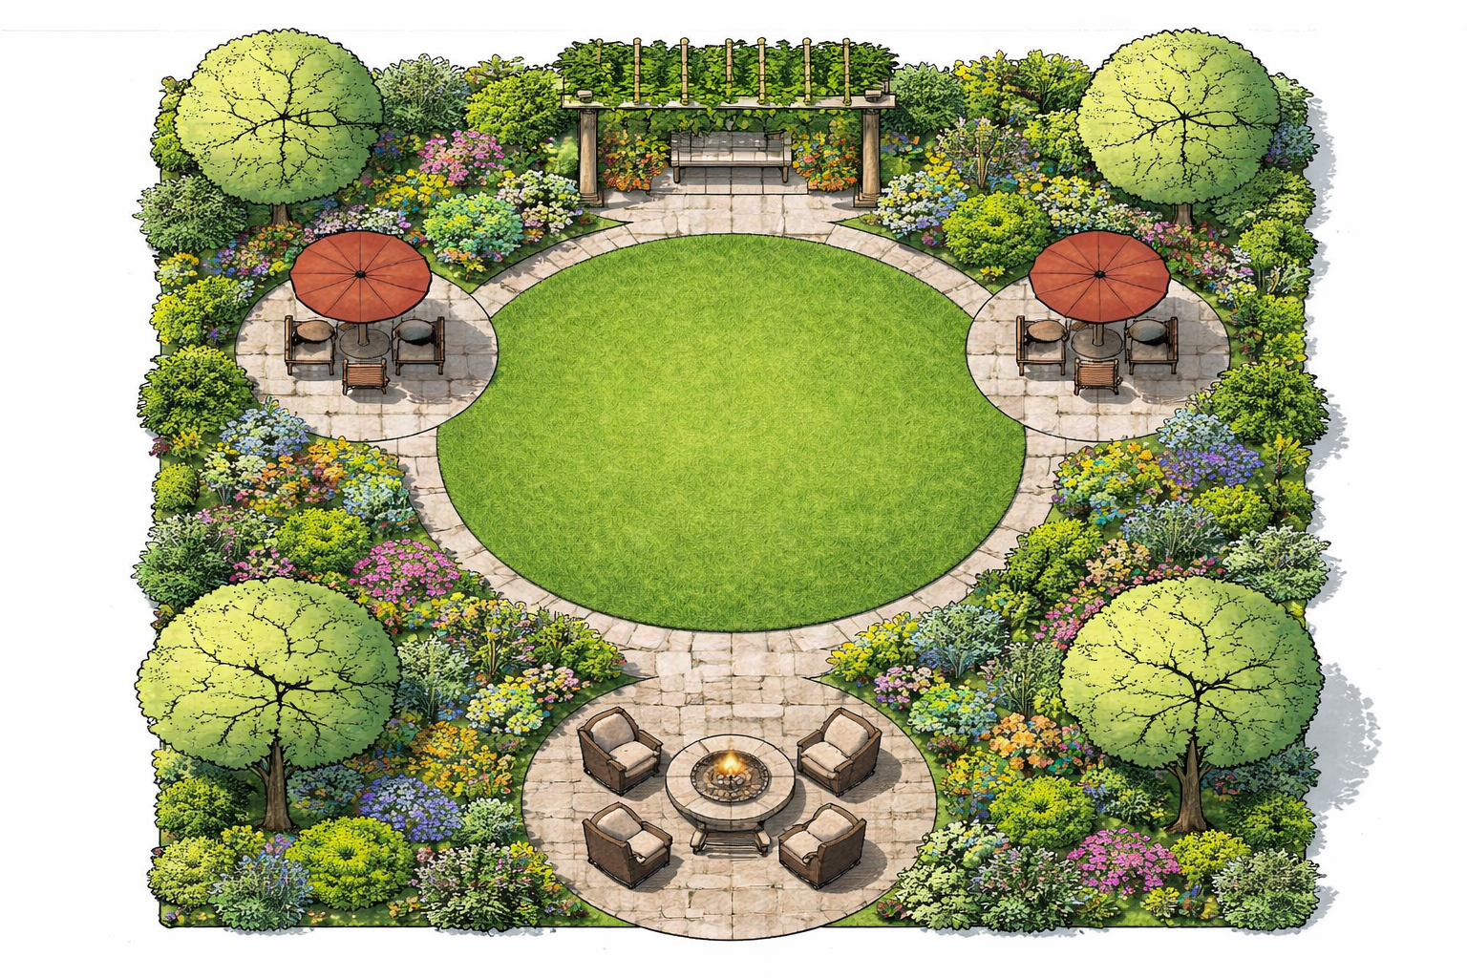  Research-Based Design Development |  |   Proposal & Technical Planning
  Establishment Care & Lifecycle Support |  | 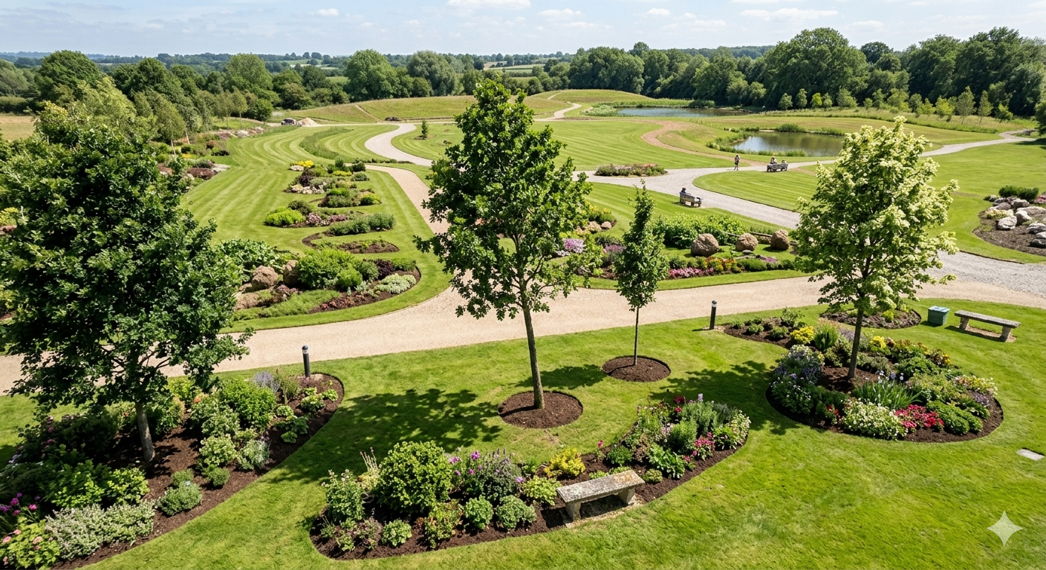  Structured Handover |  | 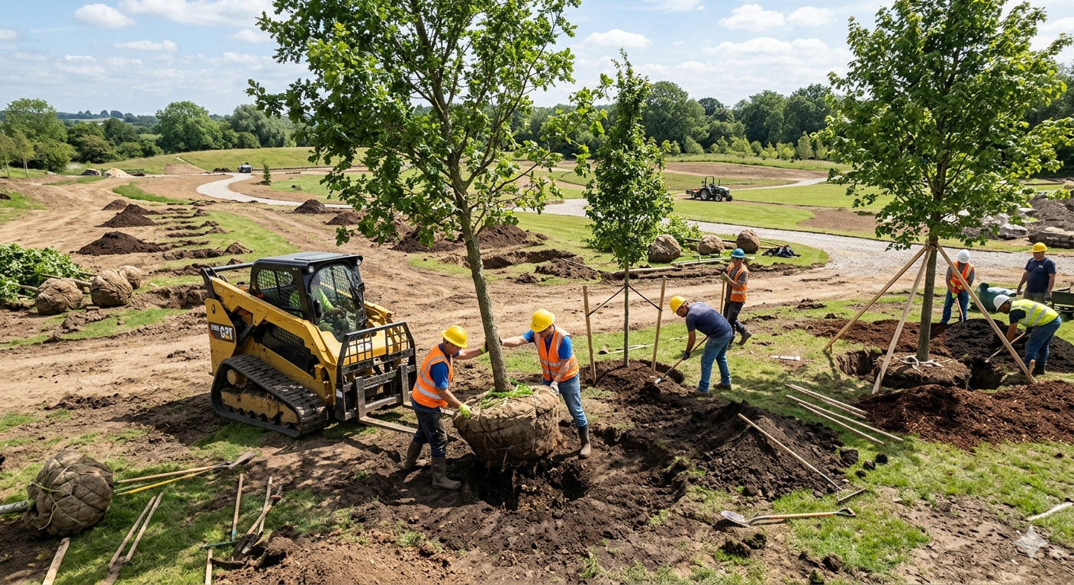 Professional Execution

Project Portfolia (Click in text/pic has to take to Project Portfolia Section)

5+  Successful Years | 4+  Projects Completed | 10+  Professionals | 30+  Gardeners | 5+  Locations Executed | 2+  Awards Winners | 3.3+  Google Rating

Type of Project: Residential/Commercial on pic right-side top
1. Pic  2. Name of Project/Service  3. Location | 1. Pic  2. Name of Project/Service  3. Location | 1. Pic  2. Name of Project/Service  3. Location | 1. Pic  2. Name of Project/Service  3. Location
1. Pic  2. Name of Project/Service  3. Location | 1. Pic  2. Name of Project/Service  3. Location | 1. Pic  2. Name of Project/Service  3. Location | 1. Pic  2. Name of Project/Service  3. Location
1. Pic  2. Name of Project/Service  3. Location | 1. Pic  2. Name of Project/Service  3. Location | 1. Pic  2. Name of Project/Service  3. Location | 1. Pic  2. Name of Project/Service  3. Location
1. Pic  2. Name of Project/Service  3. Location | 1. Pic  2. Name of Project/Service  3. Location | 1. Pic  2. Name of Project/Service  3. Location | 1. Pic  2. Name of Project/Service  3. Location
1. Pic  2. Name of Project/Service  3. Location | 1. Pic  2. Name of Project/Service  3. Location | 1. Pic  2. Name of Project/Service  3. Location | 1. Pic  2. Name of Project/Service  3. Location

SR GREENSCAPES PVT LTD
🌱 Sowing Science, Growing Beauty

Schedule a site visit

Name* Phone* City Service required*

Submit

About Us Follow Us
Based in Bengaluru | Services Links of Social Medias
Pan-India Project Execution Project Portfolia
Process
Phone: +91 9845728507, FAQ’s
+91 9113620609 Contact Us

Email: srgreenscapes@gmail.com
mdsrgreenscapes@gmail.com

